



**Title Block Attribute Mapping**

PLM-S

Damstraat 70 - B 9220 Hamme (VL), BE 0684.702.709

www.plm-s.com

**User Guide**

Table of Contents

TITLE BLOCK Attribute Mapping 1

Adding properties 1

LISP Configuration 2

am_customize Configuration 5

Attribute Mapping in Creo 10

TITLE BLOCK Attribute Mapping

**Adding properties**

Before starting the Attribute mapping in the TITLE BLOCK the CDEC server-side configuration must be completed and also the CDEC should be installed

The list of properties that needs to be mapped to the TITLE BLOCK should be provided to PLMS so that we will add those properties into **Creo Preferences** and **PLM XML Creo transfer mode**

**Cd4_Property_Order – the props must be added here also. The order in this is the order it will be displayed in the DownloadDetails.txt**

**If a property is not present in CD4_mi_Creo_Properties then remove that in Cd4_Property_Order preference also**

For example, in ANTARES the below are the list of properties that needs to be added to the **Creo Preferences** and **PLM XML transfer mode** are

* object_name
* object_desc
* date_released
* anv3_netweight
* anv3_material
* owning_user
* creation_date
* anv3Approver

**Compound**

* anv3PartID
* anv3PartRev
* anv3PartName
* anv3PartDesc
* anv3PartTreatment
* anv3PartFinishing
* anv3PartSubs

**LISP Configuration**

Once the above properties are added to the **Creo Preferences** and **PLM XML transfer mode** then follow the steps mentioned below

1. These properties should also be added in the “**am_customize**” file present in the **sd_customize\ANNOTATION** of the Creo installed location and “**cdec_get-item-id.lsp**” in the sd_customize location where the Creo is installed
2. The preferred application to use for doing the configuration of “**am_customize**” and “**cdec_get-item-id.lsp**” is Notepad++
3. Open the **cdec_get-item-id.lsp** file in Notepad++ and go to the section where the FUNCTIONS to load the properties are present

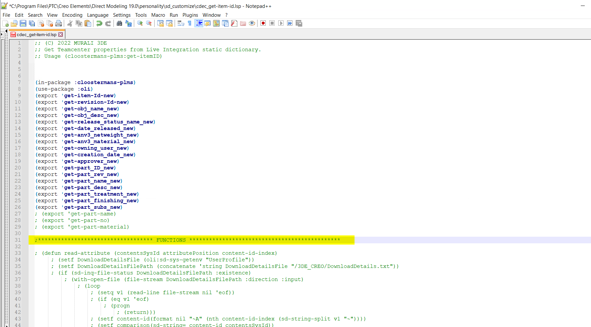

1. In the **FUNCTIONS** section go to the end of the working function and add each function for each property

For example, if the property **anv3PartSubs** has to be mapped to the title block then a function for this property has to be added to the LISP file. A function starts with **defun** and ends with the **return** statement

To add the function of the property **anv3PartSubs** copy the function which is already mentioned for another property

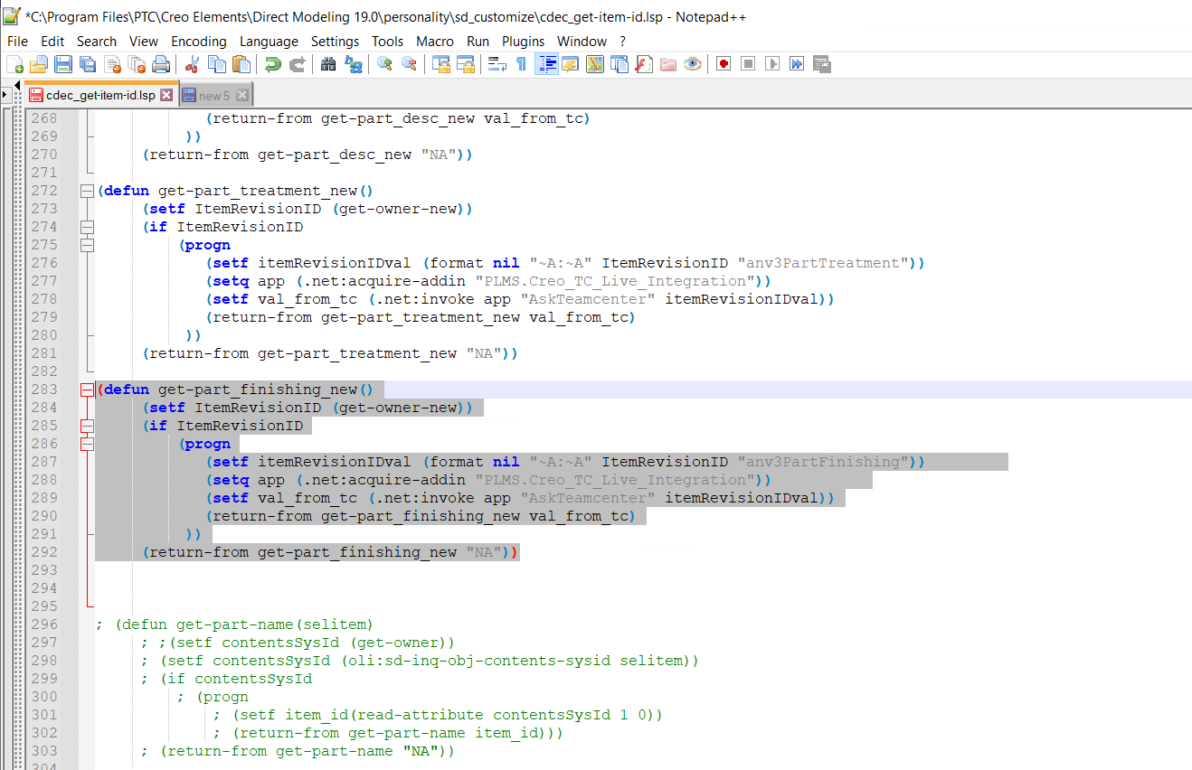

1. Paste the property at the end of the last working function

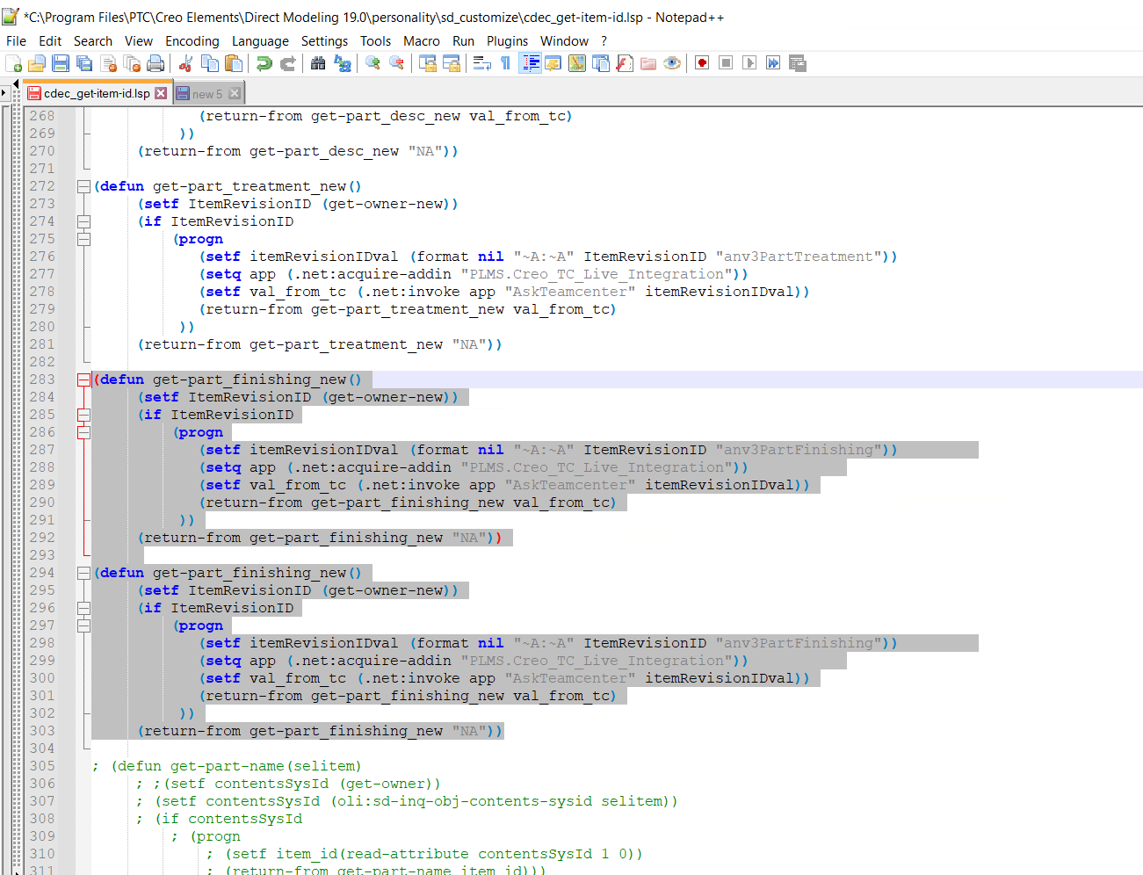

1. In the copied function the function name is **get-part_finishing_new** and this name is given based on the property name “**anv3PartFinishing**”
2. For example, let me show how to do it for a property **anv3PartSubs**, In the pasted function change the function name **get-part_subs_new** according to the property real name “**anv3PartSubs**”. The function name has to be changed in the 3 areas [1 defun and 2 return statements] of the pasted function as shown in the below image

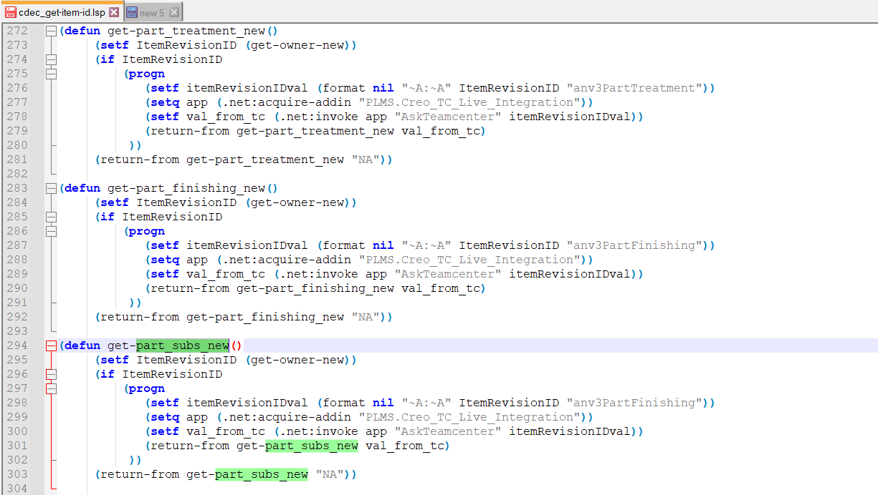

1. Now change the property real name value in the first **setf** statement as shown in the below image

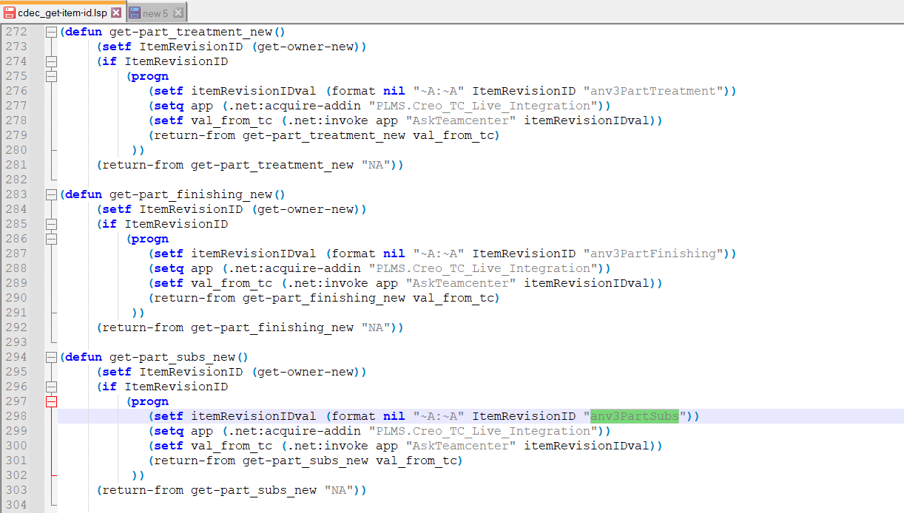

1. Once the function is added then export this function from the LISP file using the export statement. It is done by adding an export statement in the top section of the **cdec_get-item-id.lsp** with the function name that has been added

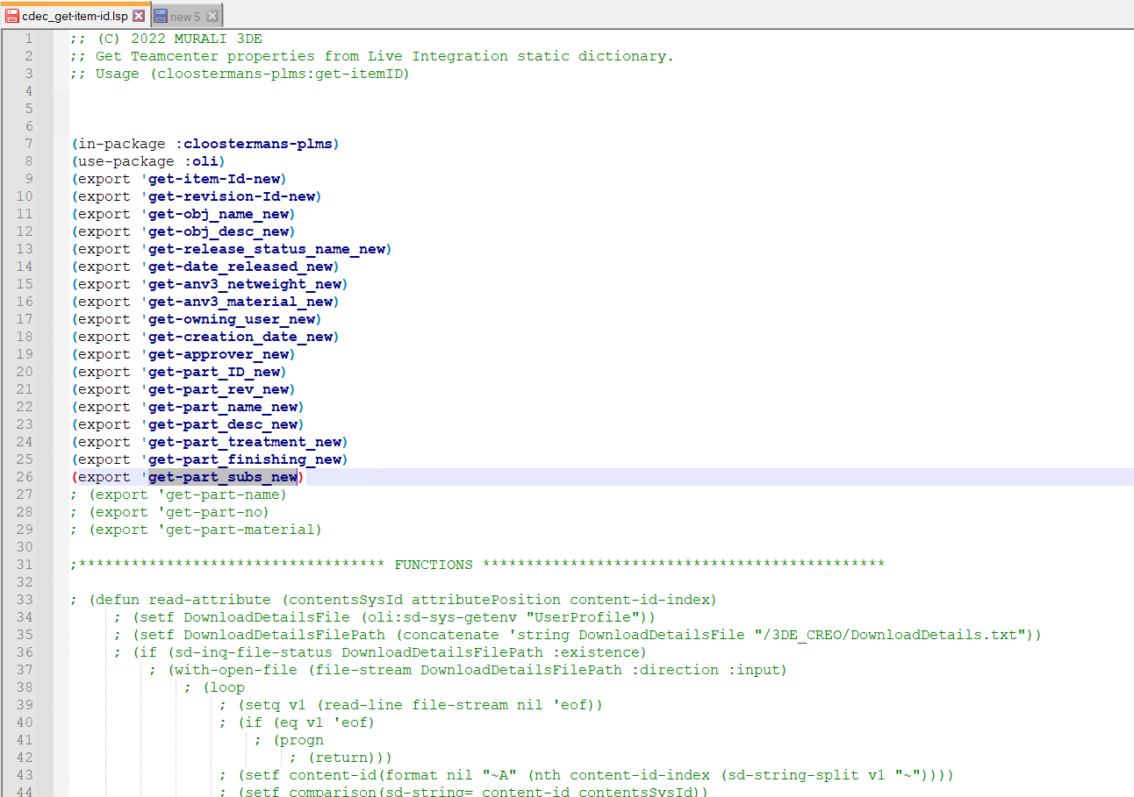

1. Once these steps are completed in the LISP file, **Save** the file

**am_customize Configuration**

1. After adding the function and exporting it to the LISP file, register the function by adding it in the “PLM-s Text Reference” section of the am_customize

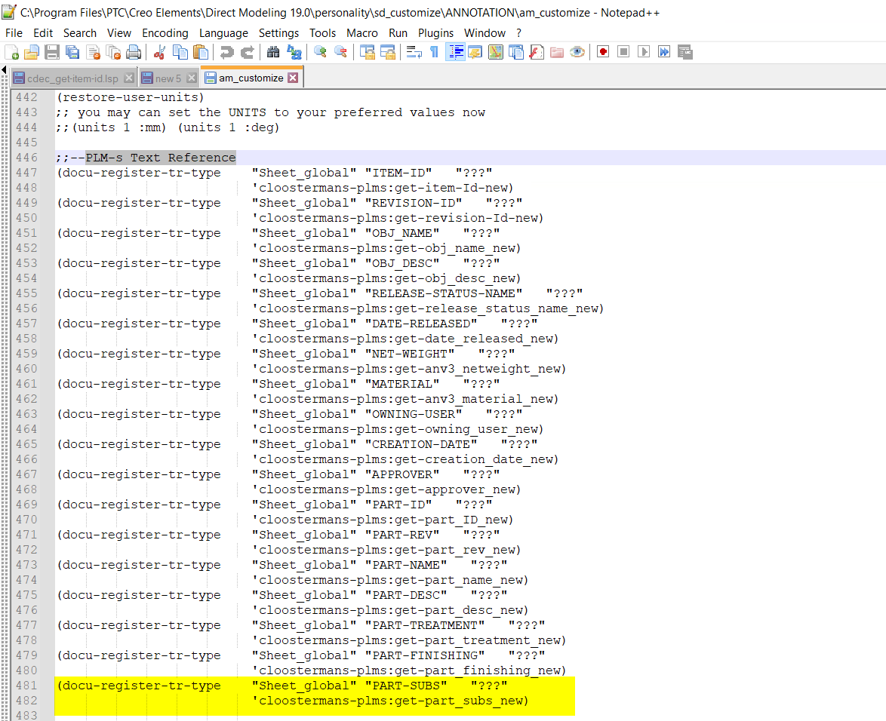

1. From the above image the user can see that I have added the **docu-register-tr-type** command for the function **get-part_subs_new**
2. The user can copy and paste an existing **docu-register-tr-type** command for another function and make changes for the newly added function. The function name is mentioned as shown in the below image

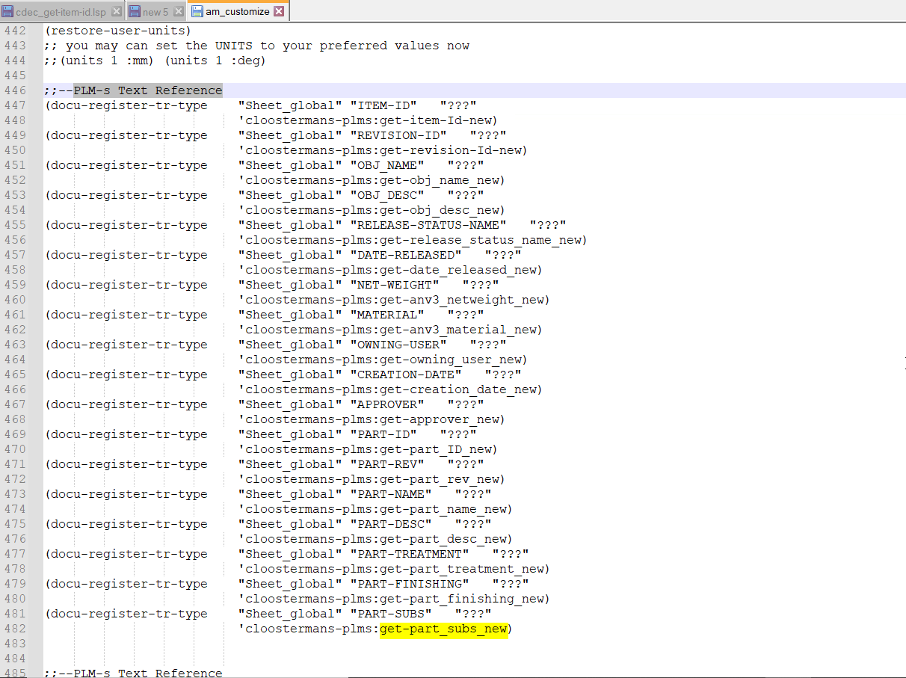

1. The name which needs to be shown in the attribute mapping of Creo should be modified. Here I have given “**PART-SUBS**” a similar name according to the property's real name for a better understanding

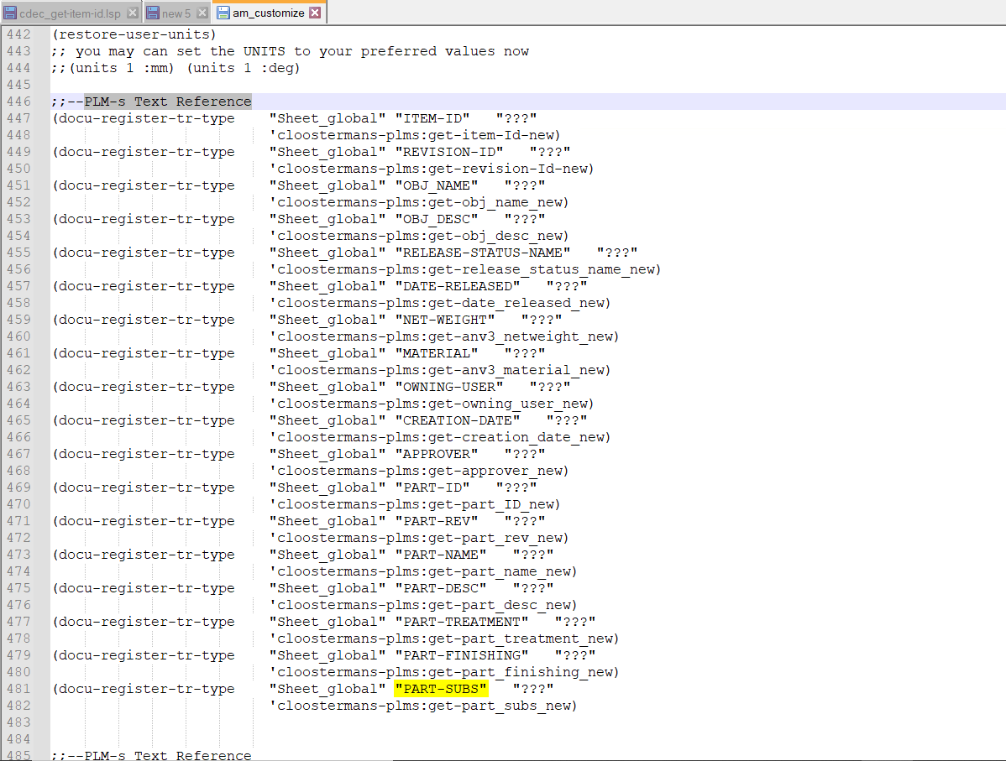

1. Add the custom templates(.mi) in a folder, the preferred location is “**sd_customize\ANNOTATION**” of the Creo installed location
2. After adding the template files in the ANNOTATION folder these templates have to be registered in the **am_customize** file by specifying the location of these template files in each docu-register-frame function in the **PLM-s Frame** section of the am_customize file as shown the below image

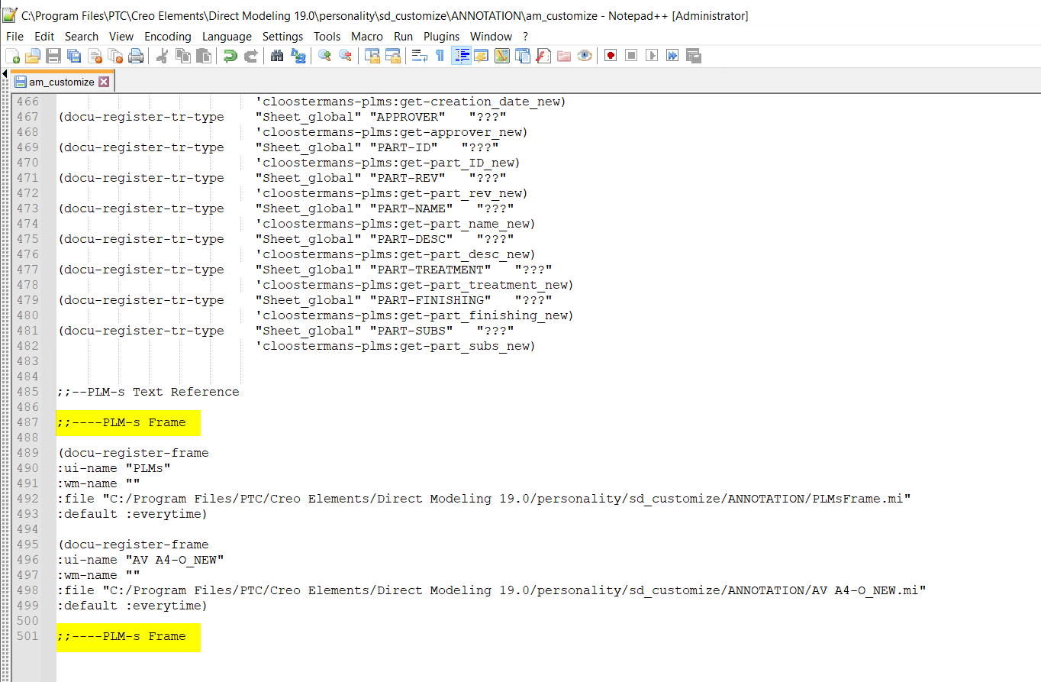

1. Users can copy the docu-register-frame function and paste it below the copied function and specify the template location along with the template name and file extension in the **:file** statement and specify the file name in the **:ui-name**

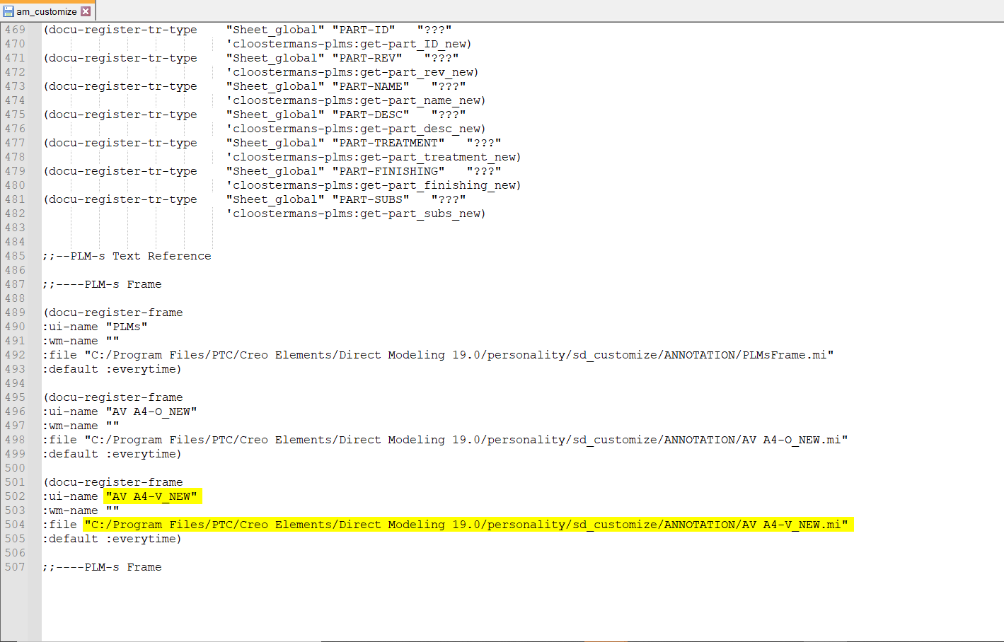

1. Likewise to register furthermore templates, add the template location as each function in the **am_customize** for which the attribute mapping that has to be done
2. Once these steps are completed in the am_customize file, **Save** the file

**Attribute Mapping in Creo**

Once After configuring the properties in the “**cdec_get-item-id.lsp**” and “**am_customize**” now user can map the attributes in the registered templates

1. Open Creo Elements Direct and load the template in the annotation module

For example, here I am have loaded the “AV A4-V_NEW.mi” template

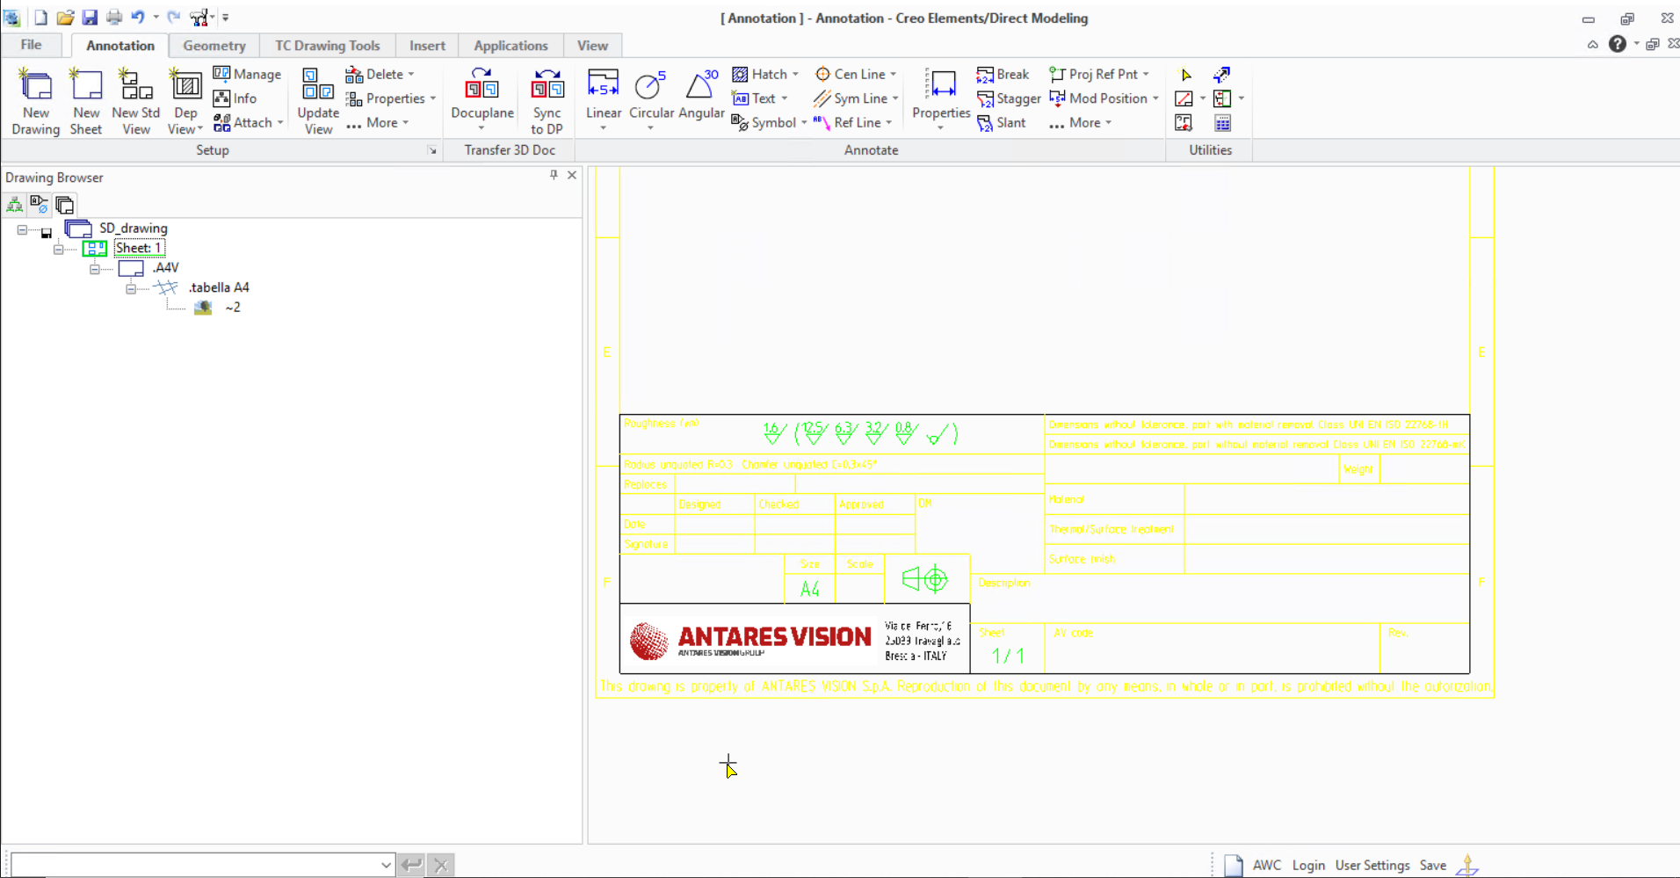

1. Now click more in the **Annotation tab** of the **Annotation module** and go to the **more** drop-down list in the **Annotate section** and click **Text Reference**

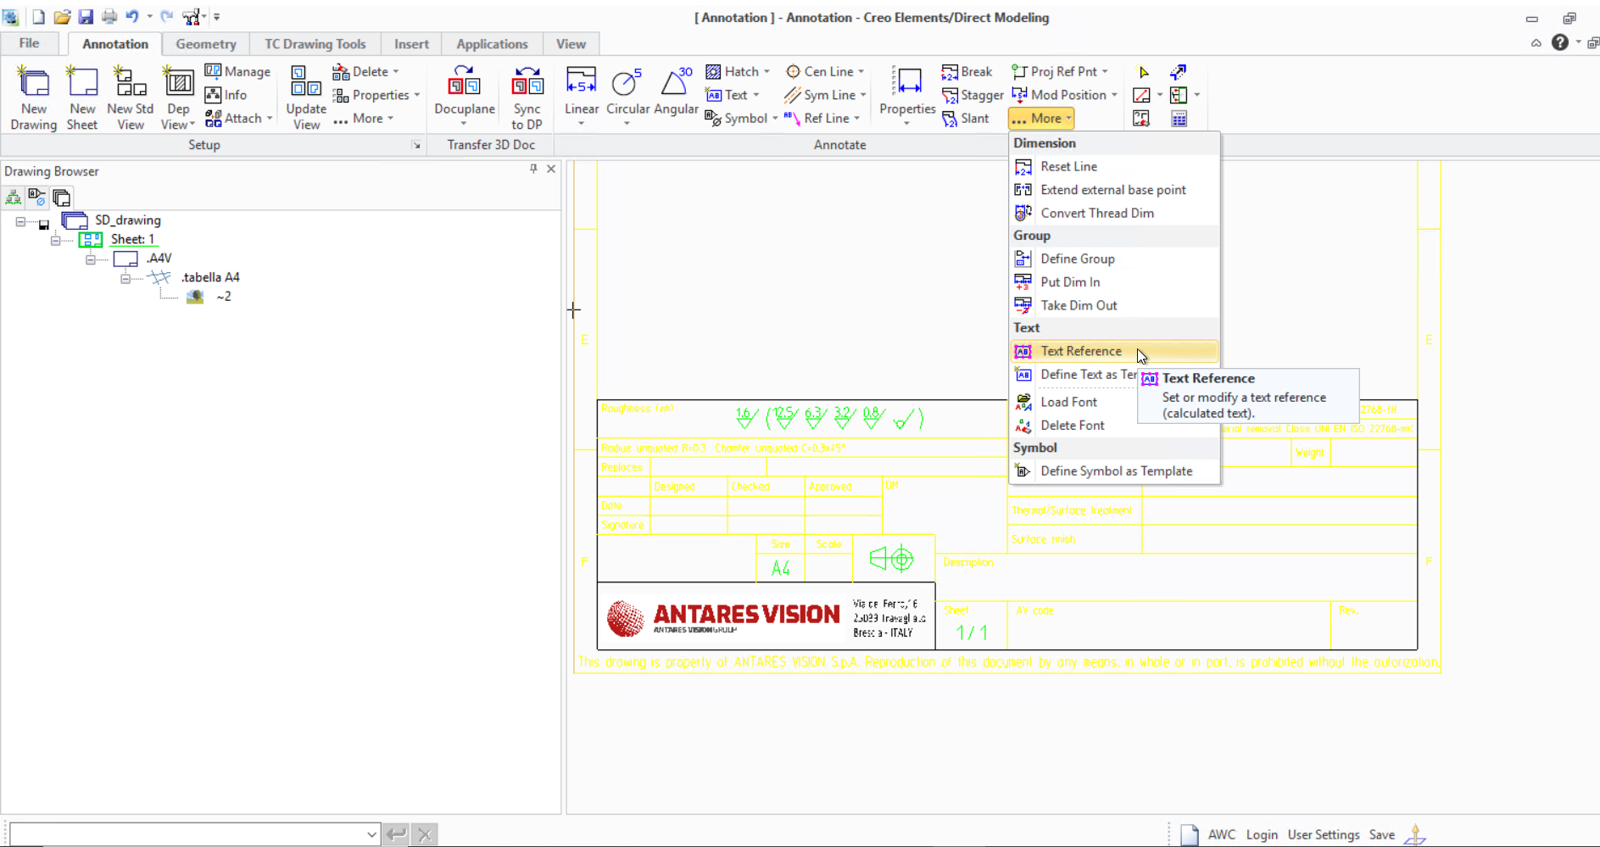

1. A **Text Reference** pop-up will appear and on the pop-up click **Assign**

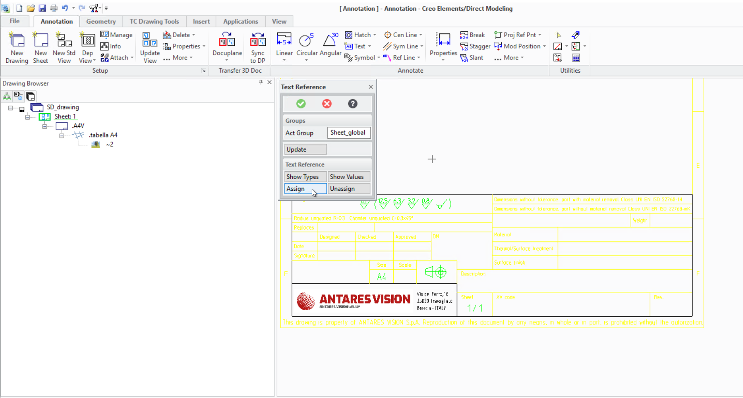

***Reference Image to get a clear view of the property cells***

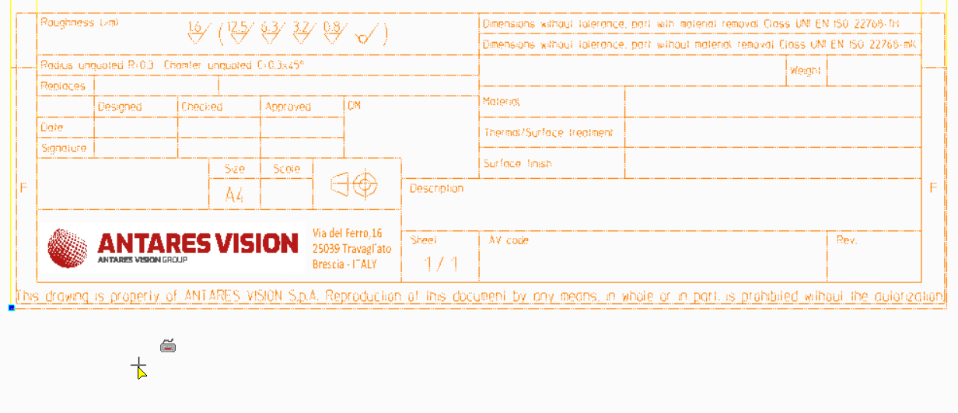

1. A table called **Text Reference Types** containing the attributes which were added in the **cdec_get-item-id.lsp** and **am_customize** files will be displayed

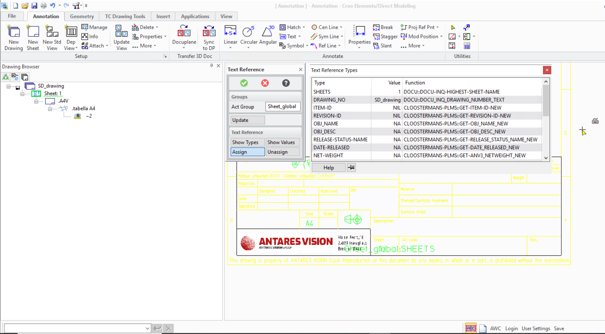

1. Select each property and then select the value box in the title block in which the following property value is to be assigned

For example, here I am selecting the **Material** attribute from the table

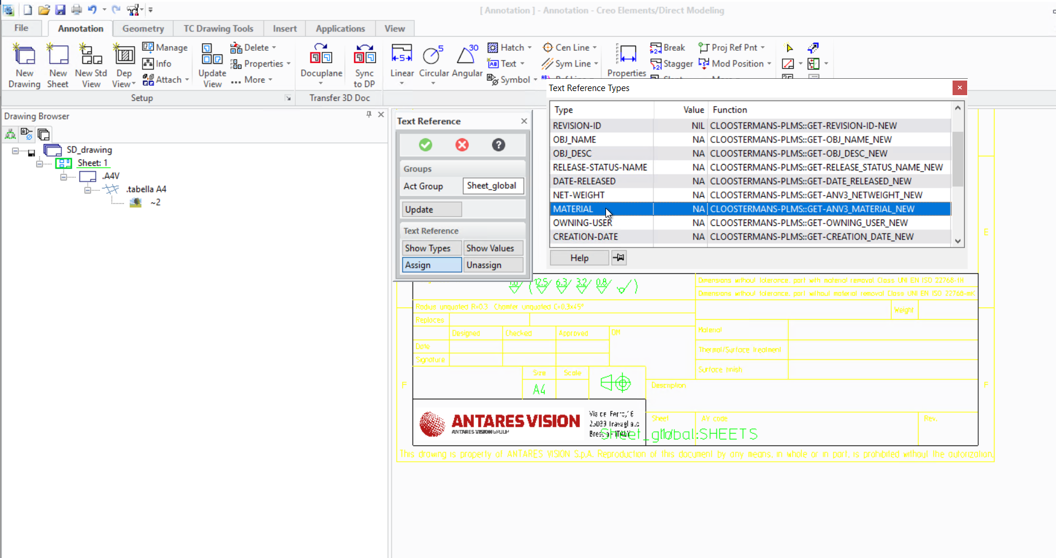

And then selecting the box in the title block where the material property value should be loaded

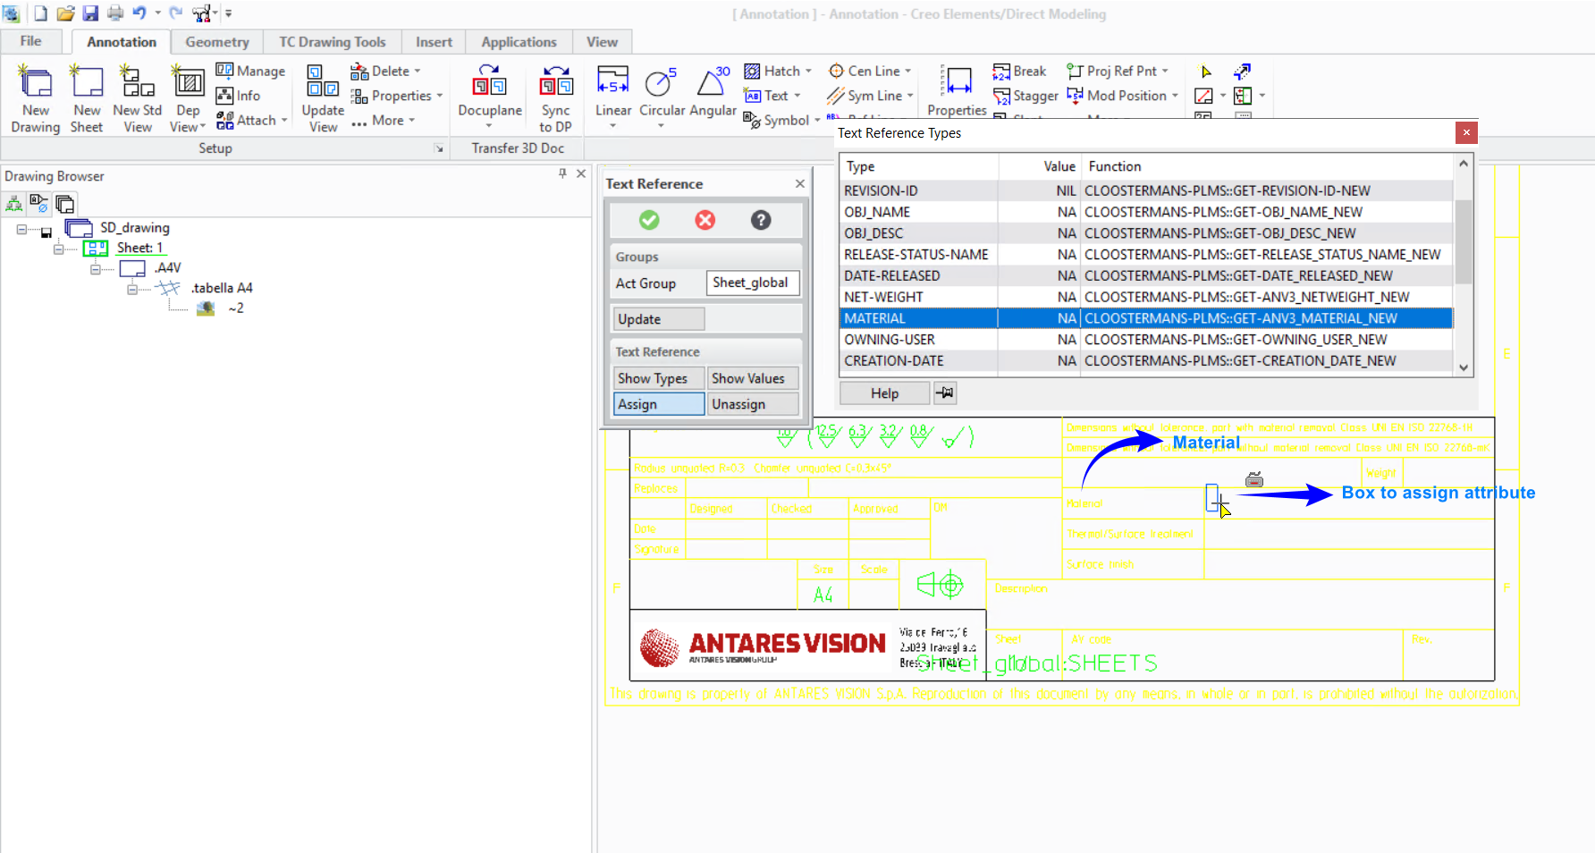

The **Material** attribute is now assigned to the selected box in the cell

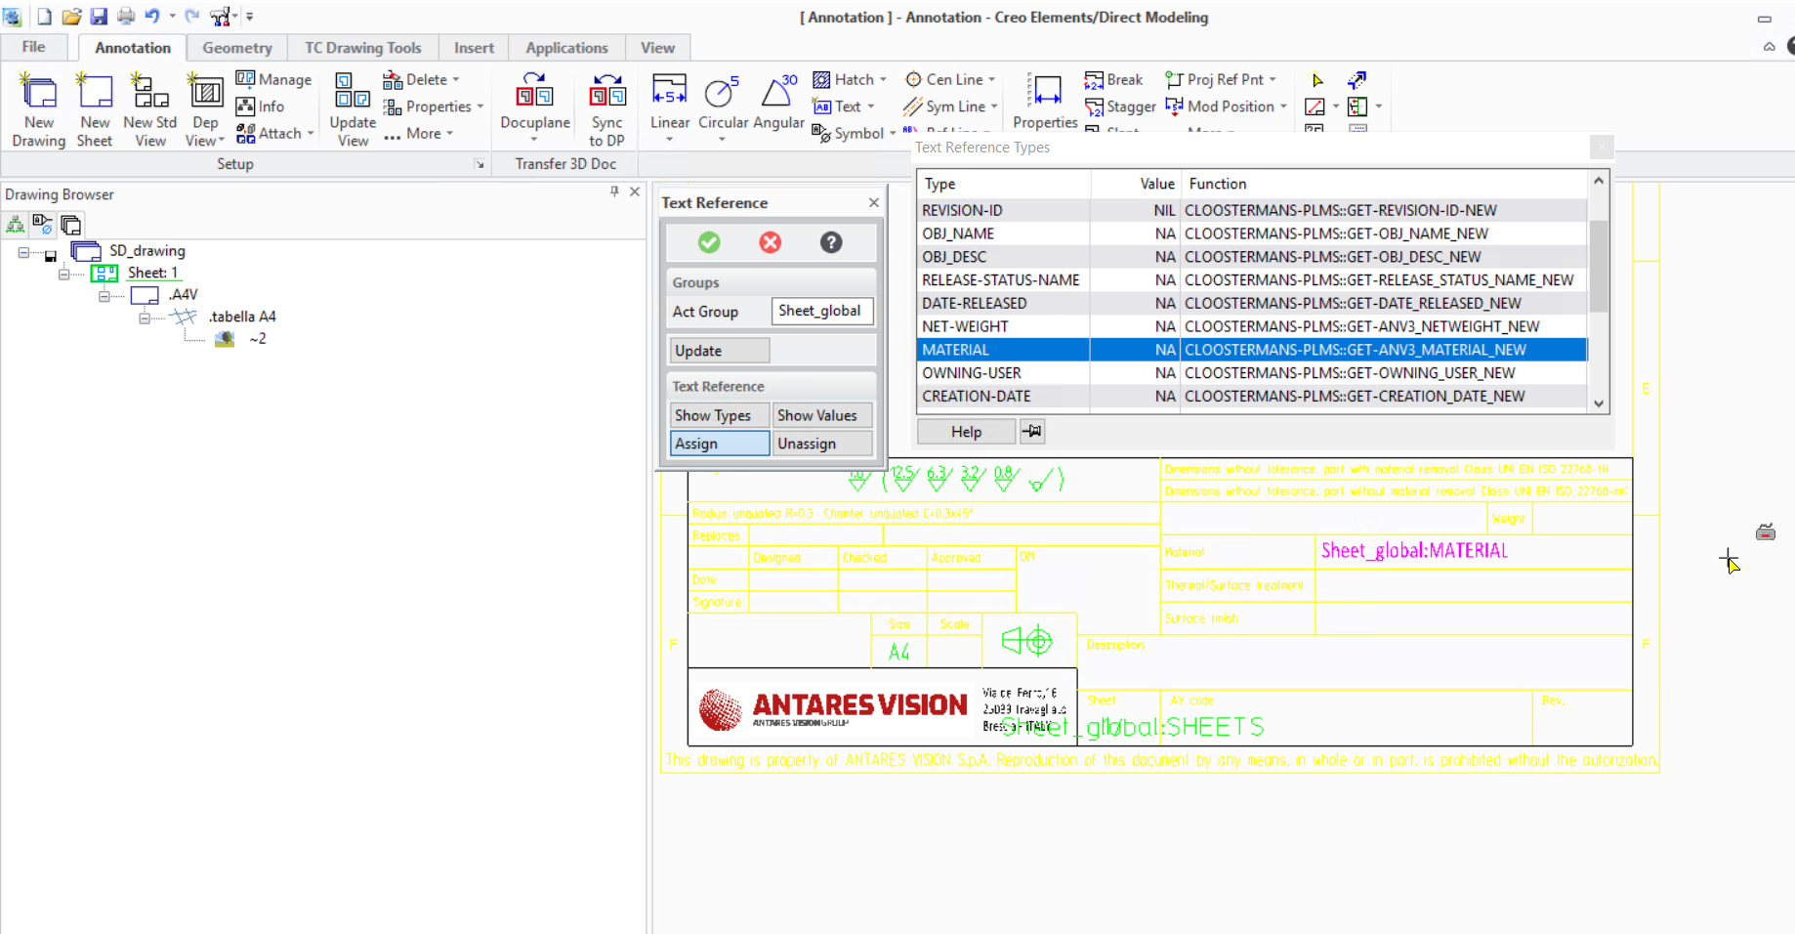

1. Likewise, repeat the steps for other properties

For **anv3PartTreatment** property

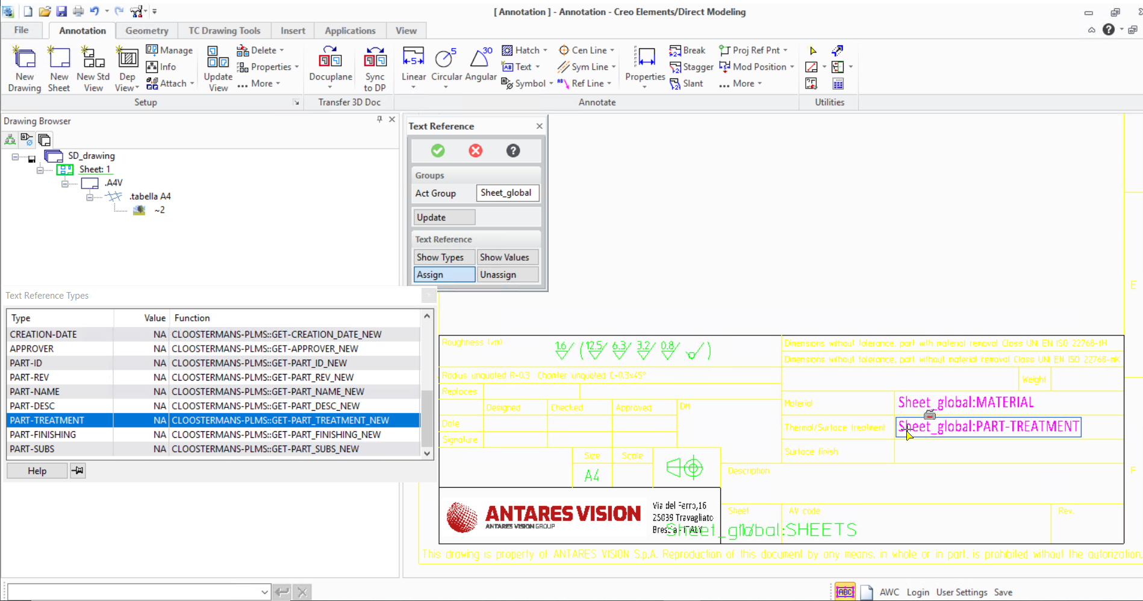

For **anv3PartFinishing** property

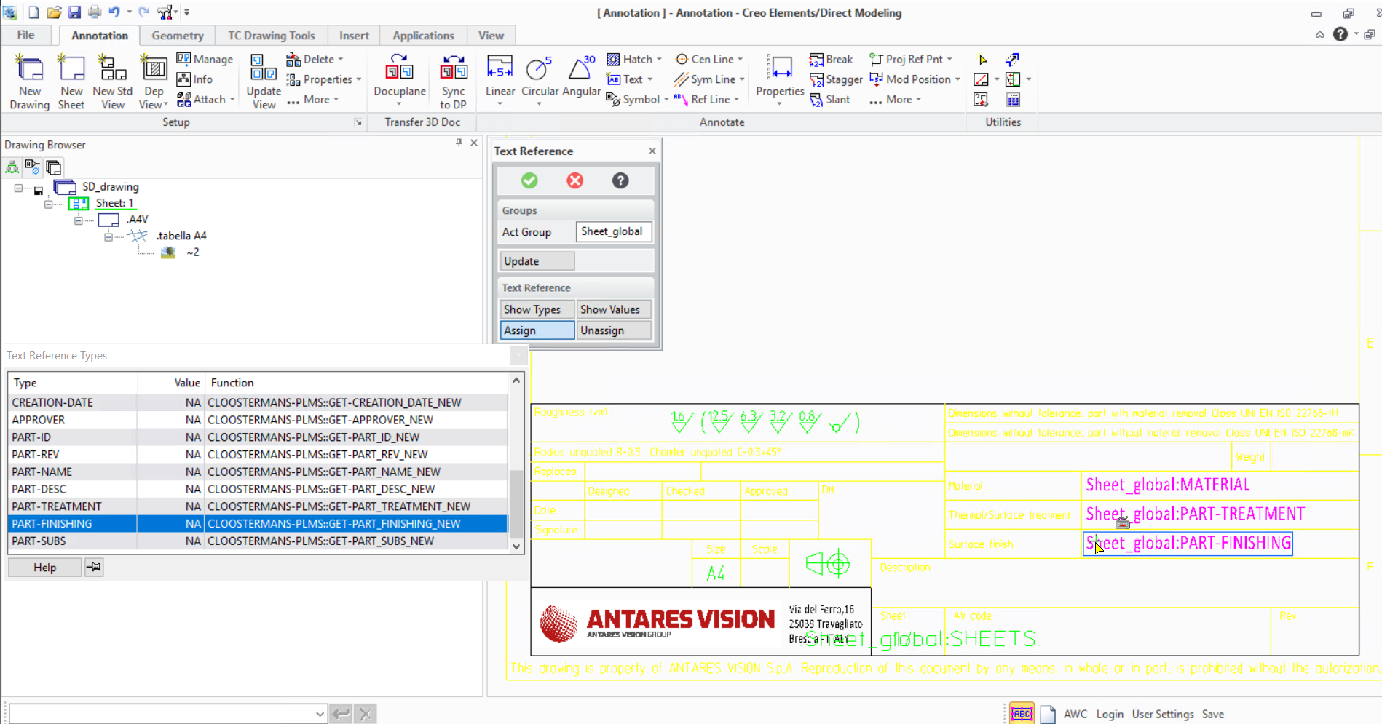

For **Item ID**

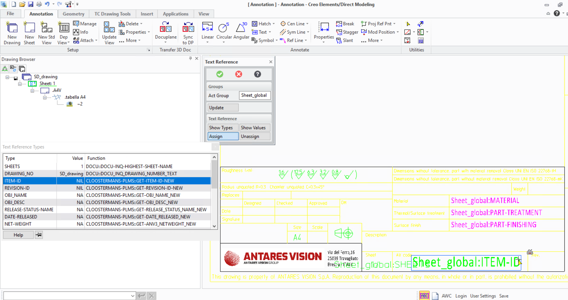

For **Item Revision ID**

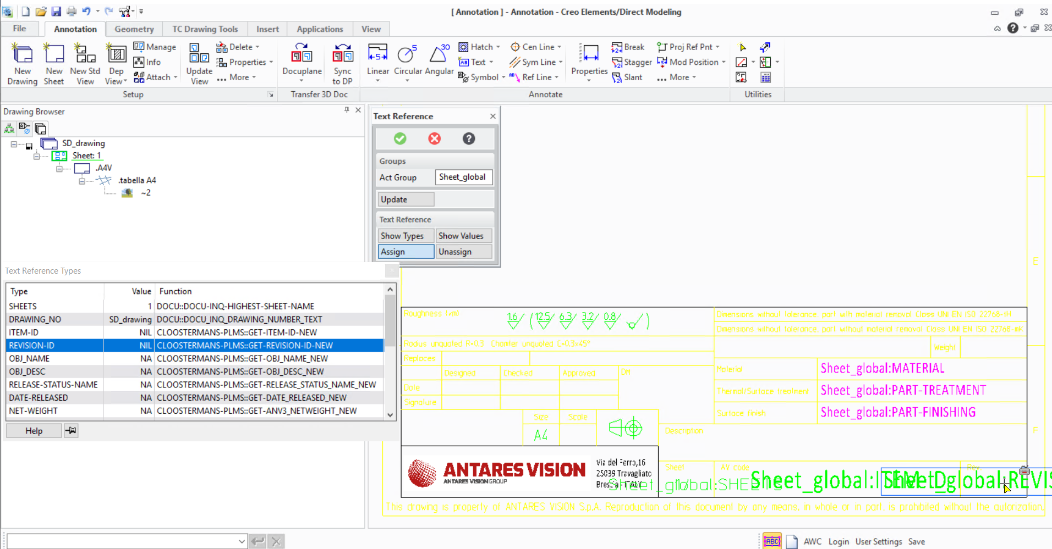

For **object_desc**

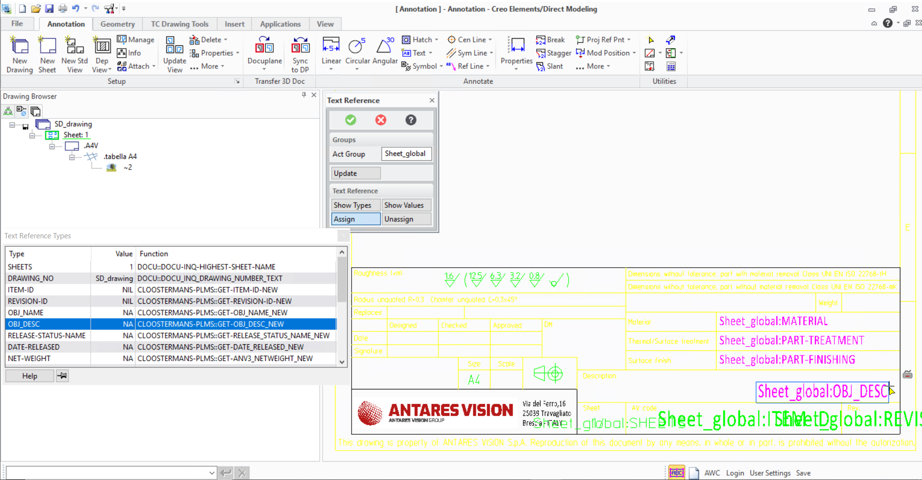

For **anv3_netweight**

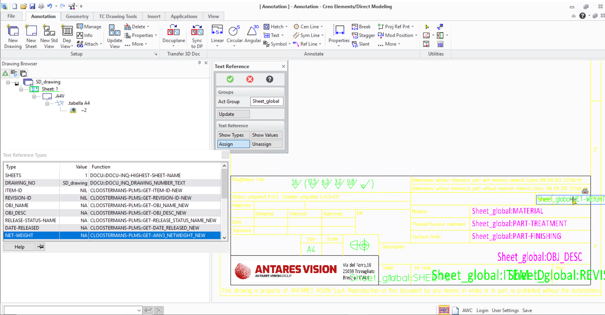

For **date_released**

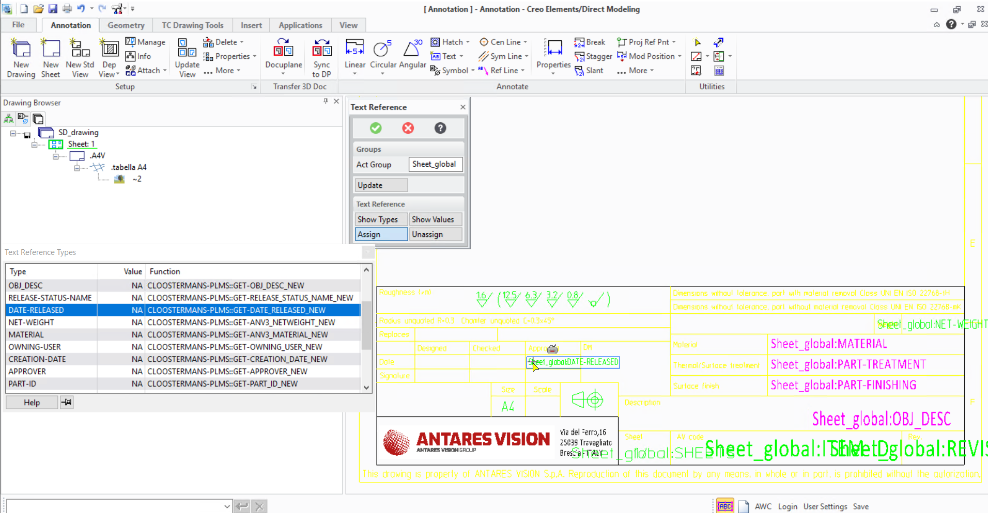

For **creation_date**

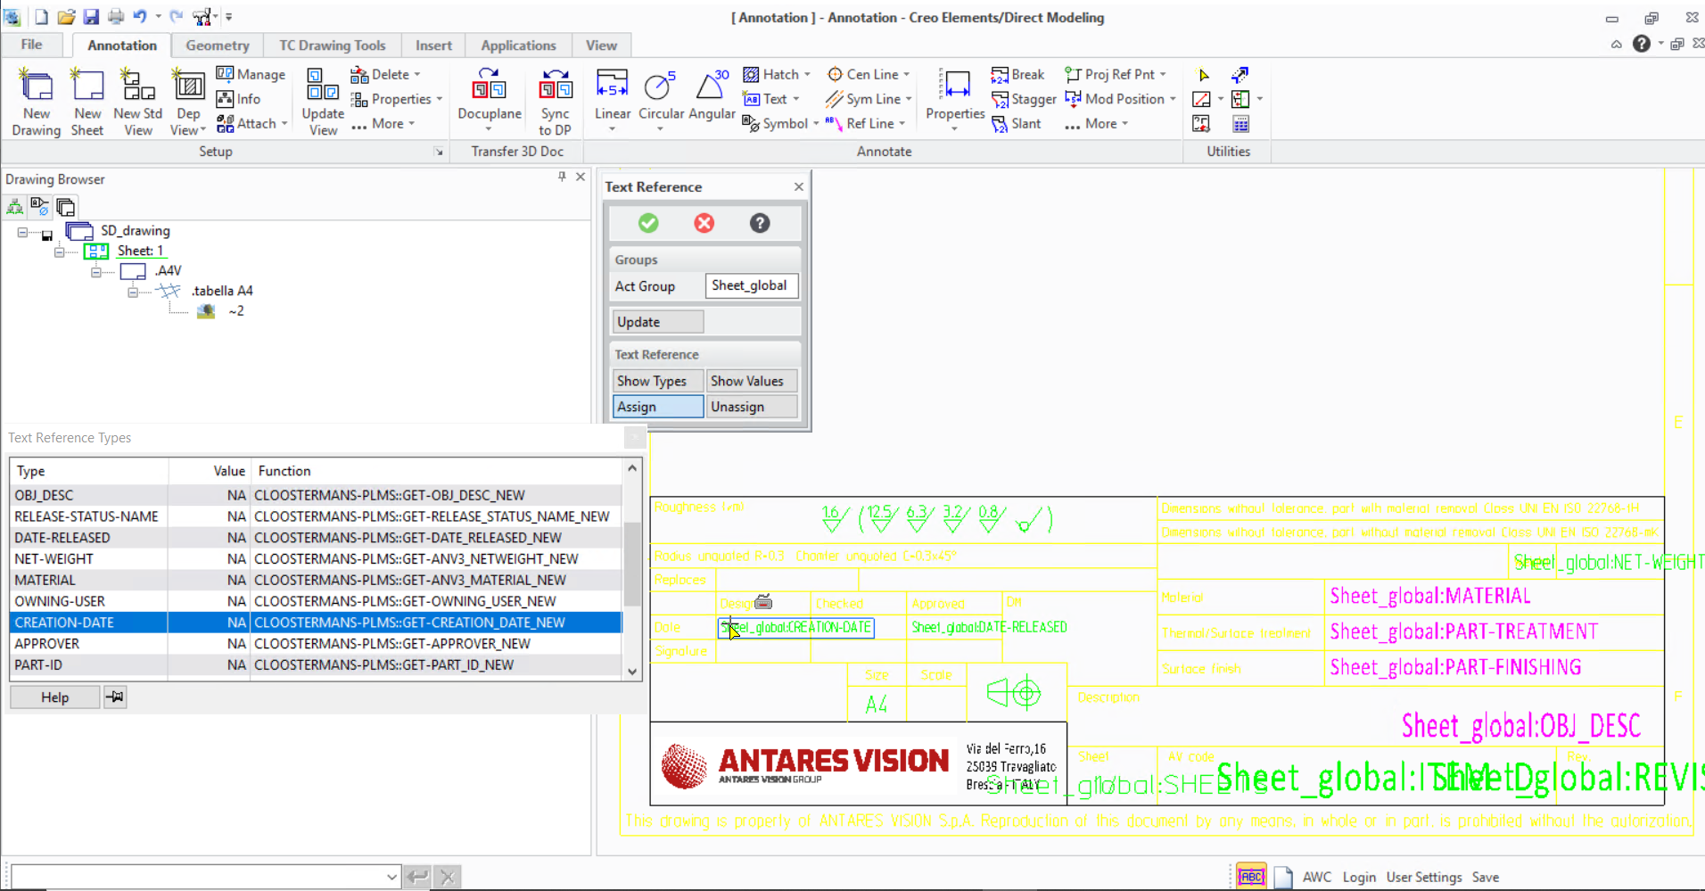

For **anv3Approver**

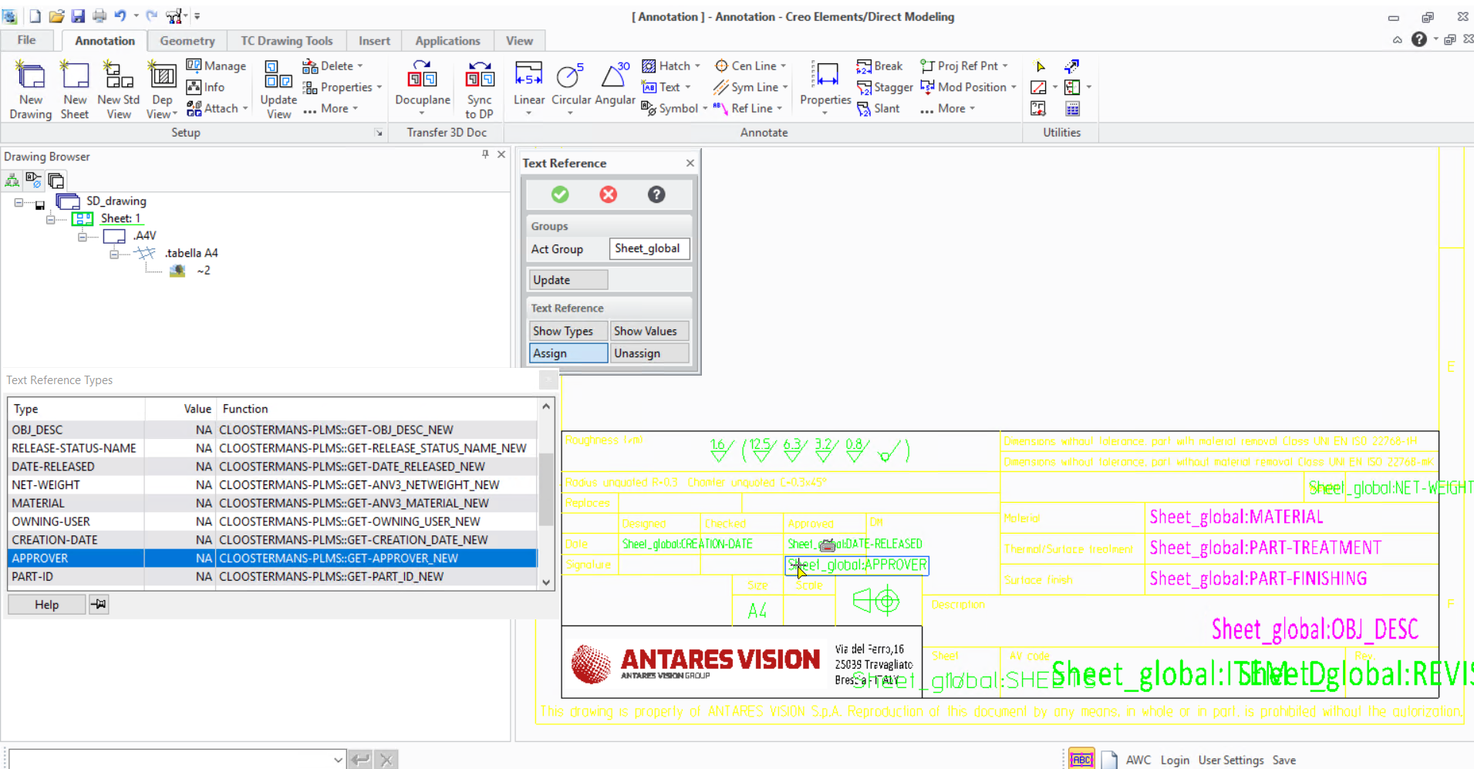

For **owning_user**

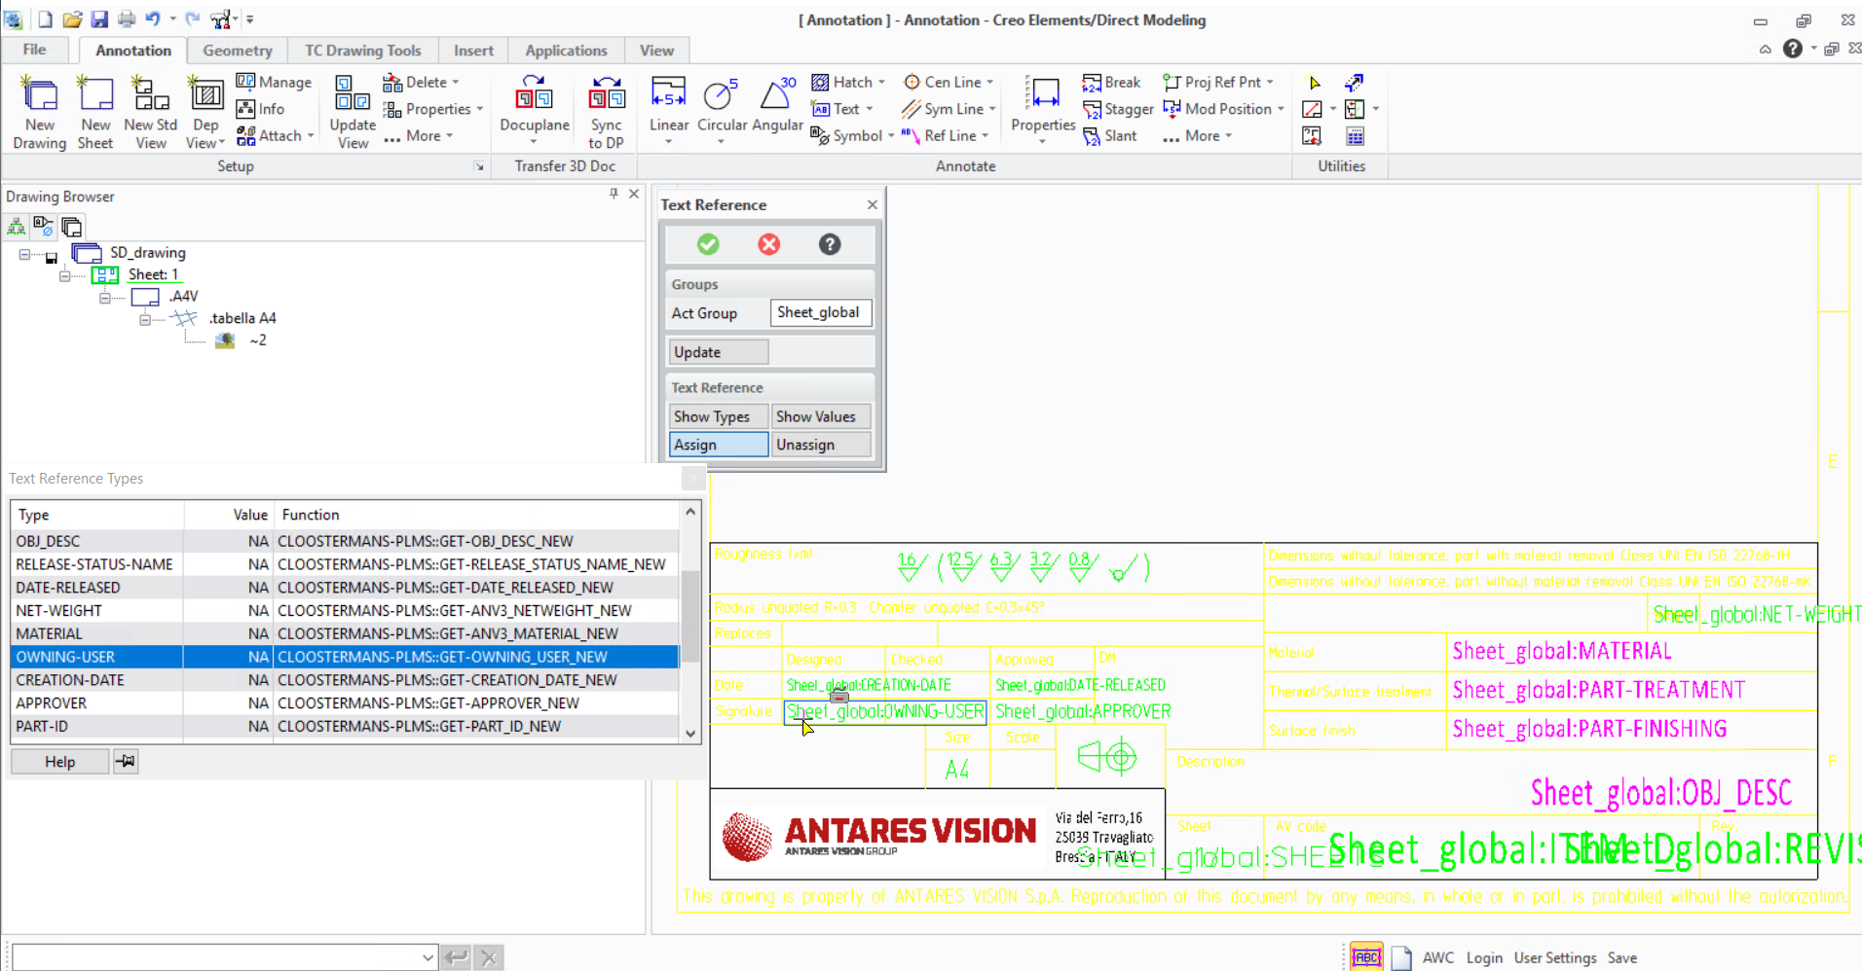

For **anv3PartSubs**

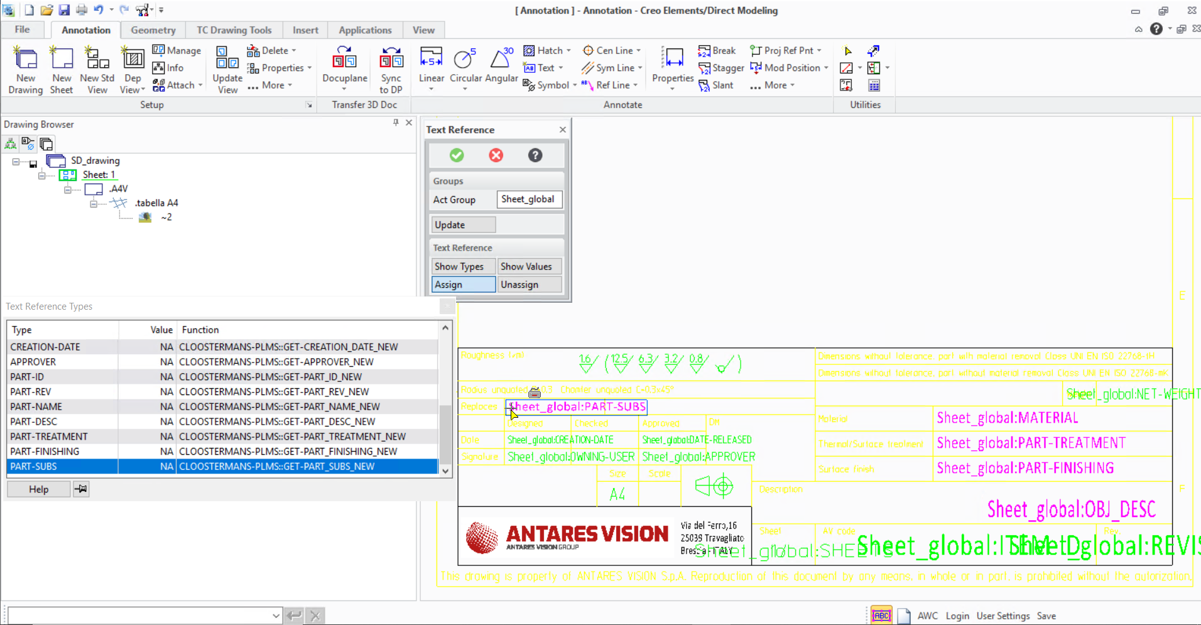

1. After assigning properties then click on the green OK icon

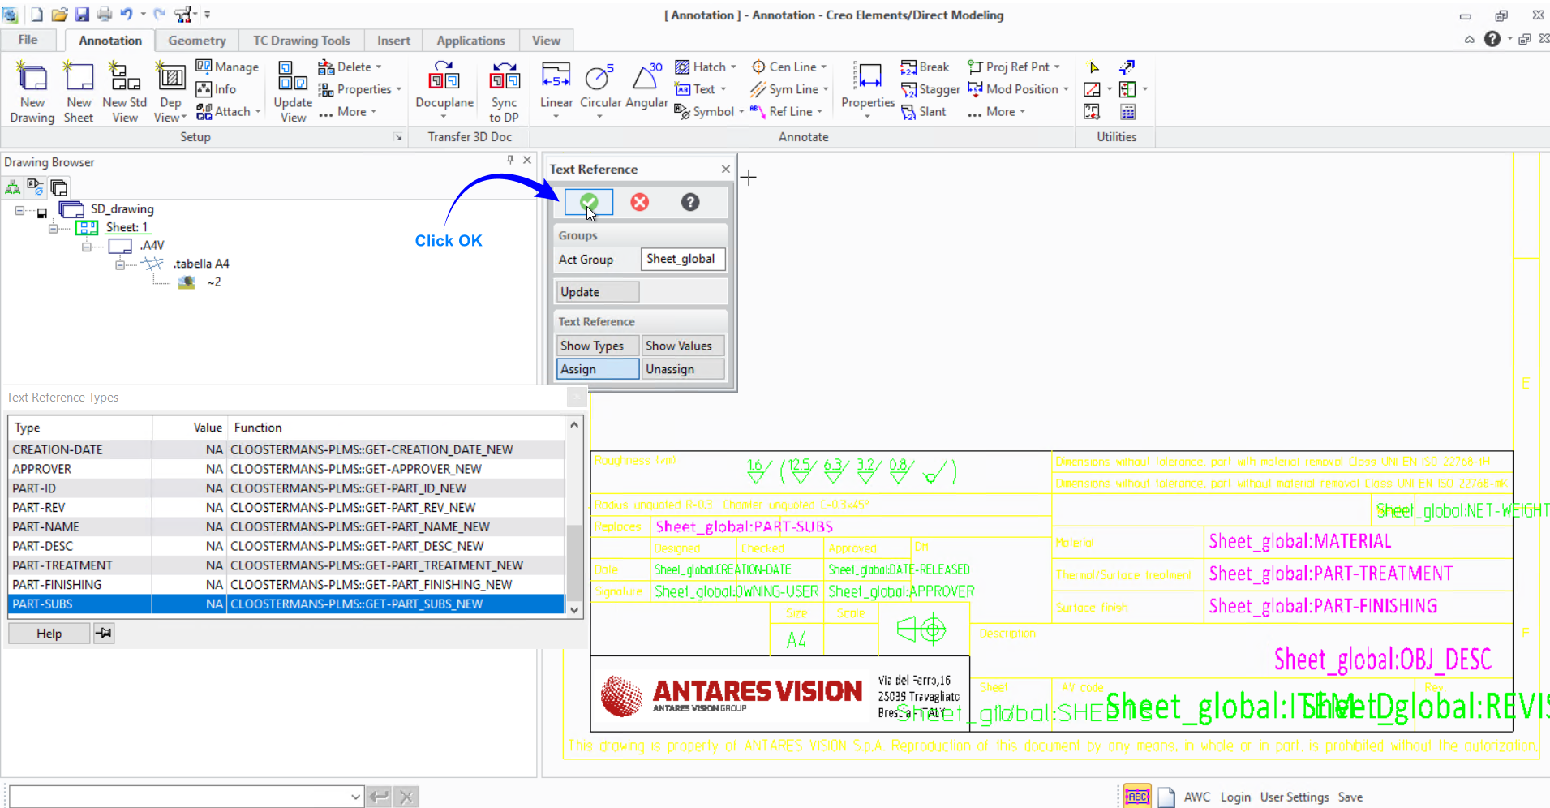

1. After assigning the required properties Click **Save** to save the changes made in the template

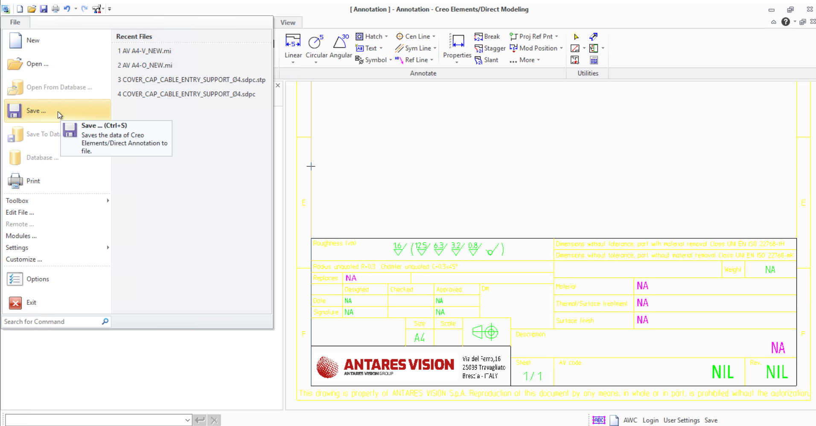

1. A Save dialog will appear and in the Save, dialog go to the location from where the template is opened and change the file type as Frame(.mi)

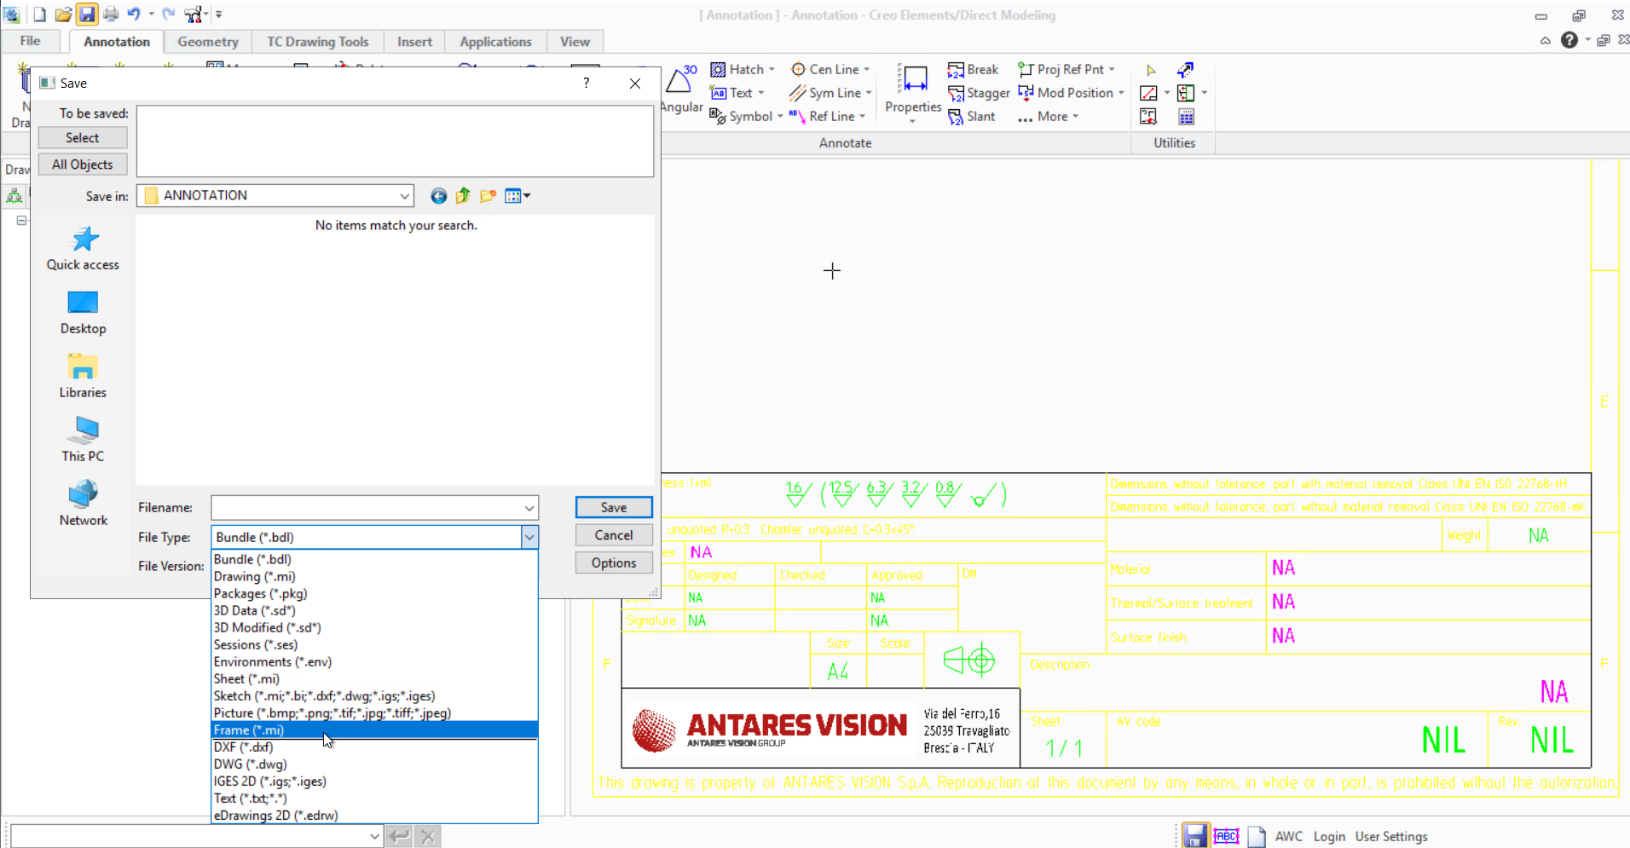

1. Click on “All Objects”

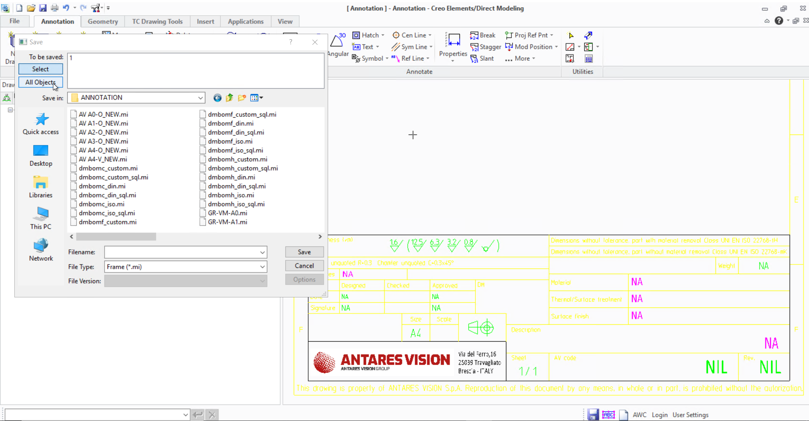

1. Select the mi file loaded and then click **Save** to save the template

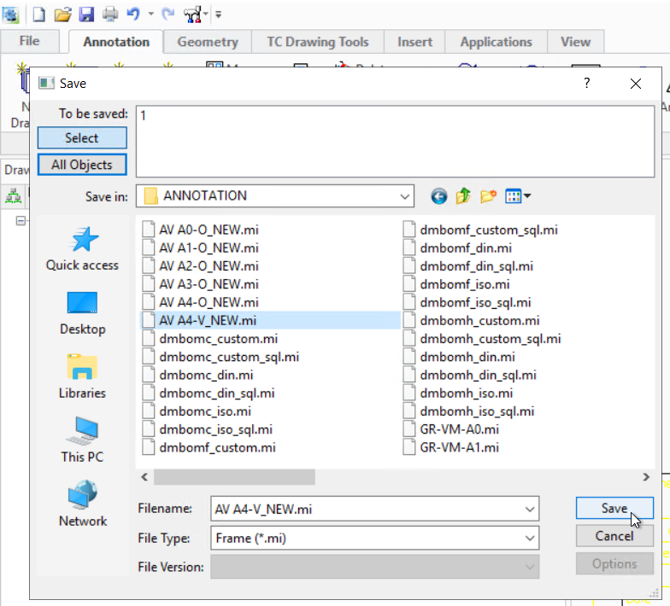

1. The user can reopen the template after saving to check whether the values are assigned to the template

***Warning: If the user is facing the write access issue during Save then the template can be saved in a different location and then replace the saved file in the location from where the template is opened in Creo***

